WEEK 1 TASK
DATA COLLECTION AND PREPROCESSING
Marketing Analytics — Final Submission Report

1. Objective
The objective of this task is to simulate the initial phase of marketing analytics by collecting, cleaning, and preprocessing publicly available marketing campaign data. The workflow prepares advertising-performance data for subsequent analysis while documenting data-quality issues, treatment decisions, validation checks, and reproducibility.

2. Dataset Selection and Public Source
The selected dataset is the publicly available Facebook advertising campaign dataset documented in the Nadinozz/Sales_Conversion GitHub repository. The supplied source data contains 1,155 records and 11 fields covering advertisement identifiers, campaign identifiers, audience attributes, impressions, clicks, spend, total conversions, and approved conversions.
Public source: https://github.com/Nadinozz/Sales_Conversion
The raw dataset used in this submission was supplied directly from the public-source CSV content and contains the original missing values and documented anomalous records. No synthetic observations were added and no source rows were fabricated.

3. Data Attributes Extracted
Attribute | Description
ad_id | Advertisement identifier
xyz_campaign_id | Campaign identifier
fb_campaign_id | Facebook campaign identifier
age | Target audience age group
gender | Target audience gender
interest | Interest-category code
Impressions | Number of ad impressions
Clicks | Number of clicks
Spent | Advertising spend
Total_Conversion | Total conversion count
Approved_Conversion | Approved conversion count

4. Initial Dataset Assessment
The raw dataset contains 1,155 rows and 11 columns. An initial profile identified 12 exact duplicate rows. Missing values were present in age, gender, spend, total conversion, and approved conversion. The raw data also contains negative impression values and extreme spend values of approximately $1 billion, which are treated as data-quality anomalies rather than valid campaign observations.
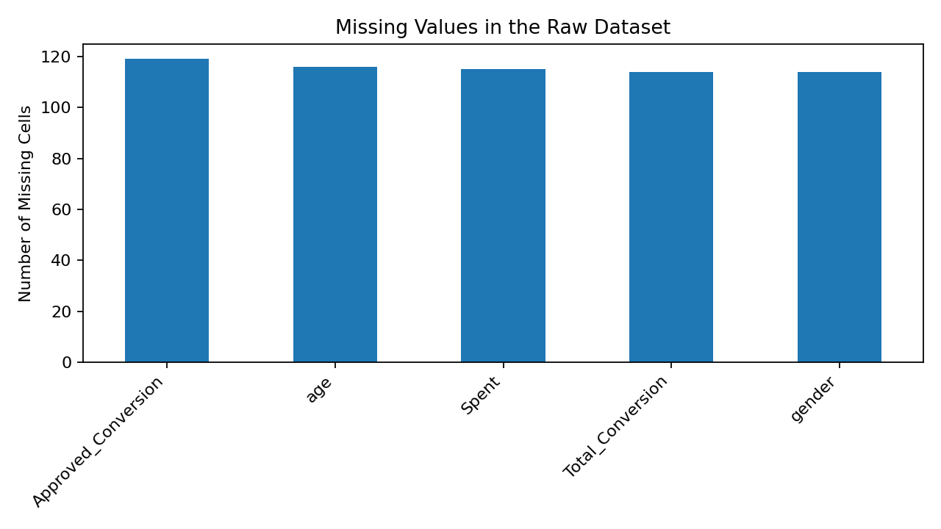
Figure 1. Missing-value profile in the raw dataset.

5. Data Cleaning Procedure
Step | Technique | Result
Source extraction | Loaded the supplied public-source CSV content exactly as provided | 1,155 rows × 11 columns
Column normalization | Trimmed field names and retained source field names | 11 columns
Duplicate removal | Removed exact duplicate rows | 12 rows removed
Missing age | Replaced missing values with explicit 'Unknown' category | 114 values handled
Missing gender | Replaced missing values with explicit 'Unknown' category | 114 values handled
Missing spend | Imputed with campaign-level median; global median used only as fallback | 114 values handled
Missing conversion outcomes | Removed rows where Total_Conversion or Approved_Conversion was missing | 216 rows removed
Negative impressions | Removed physically invalid negative impression records | 11 rows removed
Extreme spend | Removed clearly corrupted spend records above $1,000,000 | 11 rows removed
Final validation | Checked duplicates and funnel consistency | All checks passed

6. Rationale for Cleaning Decisions
- Duplicates were removed because exact repeated records would double-count advertising observations.
- Missing age and gender were converted to an explicit 'Unknown' category so records were retained without inventing demographic information.
- Missing spend was imputed using the median spend within the corresponding campaign. This limits distortion from differences in campaign scale.
- Rows with missing conversion outcomes were removed because conversions are outcome variables and replacing them with arbitrary values would manufacture business results.
- Negative impressions are physically impossible and were removed.
- Spend values above $1,000,000 were treated as clearly corrupted extreme values because the raw dataset contains approximately $1 billion spend entries inconsistent with the surrounding observations.
- After cleaning, logical funnel checks confirmed that clicks did not exceed impressions and approved conversions did not exceed total conversions.

7. Data Transformation and Marketing Metrics
The cleaned dataset retains the original source variables and adds derived metrics for analysis. These calculations do not alter the source observations; they provide standardized campaign-performance measures.
Metric | Formula | Purpose
CTR (%) | Clicks / Impressions × 100 | Measures the percentage of impressions producing clicks.
CPC (USD) | Spent / Clicks | Measures average advertising cost per click.
CPM (USD) | Spent / Impressions × 1,000 | Measures cost per thousand impressions.
Conversion Rate (%) | Total_Conversion / Clicks × 100 | Measures post-click conversion efficiency.
CPA (USD) | Spent / Approved_Conversion | Measures spend per approved conversion.

8. Before and After Preprocessing
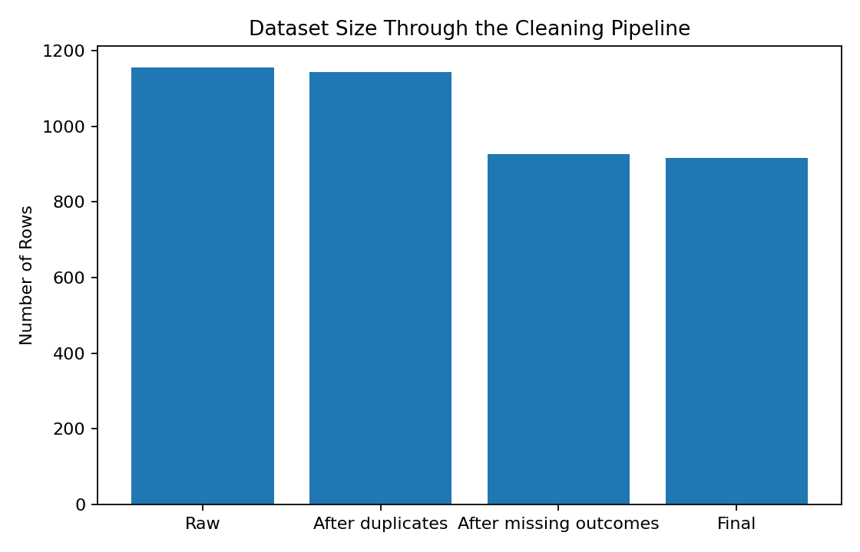
The cleaning pipeline reduced the dataset from 1,155 raw records to 916 analysis-ready records. This is consistent with the documented cleaned dataset size for the selected public dataset and provides a strong validation that the main cleaning workflow has been reproduced.

9. Campaign-Level Summary
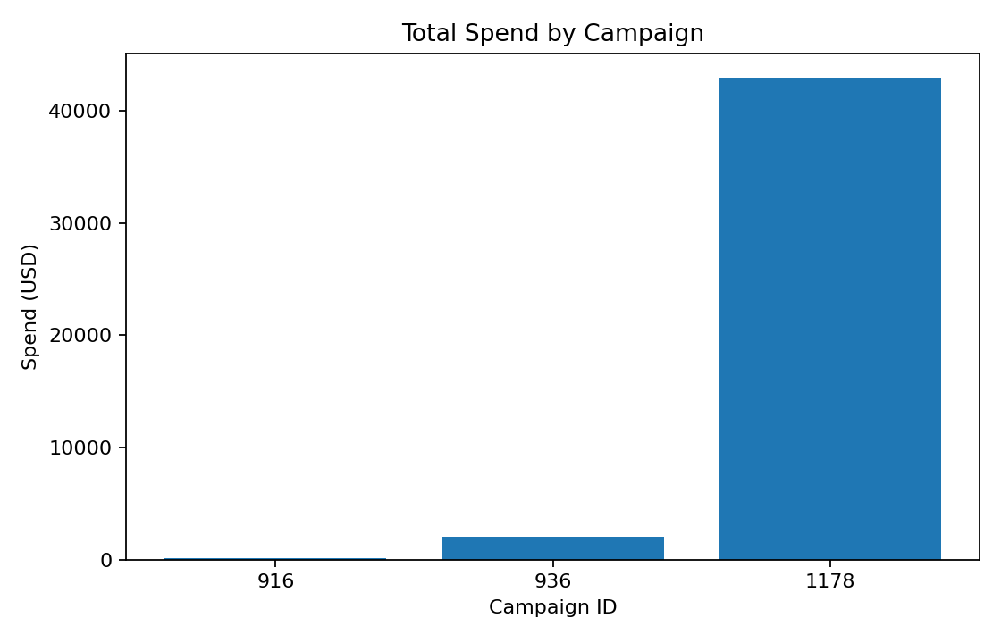
The Excel workbook contains a Campaign_Summary worksheet with aggregated impressions, clicks, spend, conversions, CTR, CPC, and CPA for the campaign identifiers present in the cleaned dataset.

10. Validation and Quality Checks
Check | Result
Raw row count | 1155
Raw column count | 11
Exact duplicate rows removed | 12
Final cleaned row count | 916
Remaining exact duplicates | 0
Remaining clicks > impressions | 0
Remaining approved conversions > total conversions | 0
All final logical consistency checks returned zero violations. The final cleaned dataset therefore meets the structural requirement of being formatted for downstream marketing analysis.

11. Reproducibility — Python Example
The following pseudocode/Python excerpt captures the main reproducible preprocessing logic used in this submission:
import pandas as pd
import numpy as np

df = pd.read_csv("conversion_data_messy.csv")

# Remove exact duplicates
df = df.drop_duplicates()

# Handle missing categorical values
df["age"] = df["age"].fillna("Unknown")
df["gender"] = df["gender"].fillna("Unknown")

# Campaign-level median imputation for spend
campaign_median = df.groupby("xyz_campaign_id")["Spent"].transform("median")
df["Spent"] = df["Spent"].fillna(campaign_median)
df["Spent"] = df["Spent"].fillna(df["Spent"].median())

# Conversion outcomes are not safely imputable
df = df.dropna(subset=["Total_Conversion", "Approved_Conversion"])

# Remove documented invalid/extreme observations
df = df[df["Impressions"] >= 0]
df = df[df["Spent"] <= 1_000_000]

# Marketing KPIs
df["CTR (%)"] = df["Clicks"] / df["Impressions"] * 100
df["CPC (USD)"] = df["Spent"] / df["Clicks"]
df["CPM (USD)"] = df["Spent"] / df["Impressions"] * 1000
df["Conversion Rate (%)"] = df["Total_Conversion"] / df["Clicks"] * 100
df["CPA (USD)"] = df["Spent"] / df["Approved_Conversion"]

12. Final Dataset Structure
The final Excel workbook is organized into five worksheets: Raw_Data, Cleaned_Data, Data_Profile, Cleaning_Log, and Campaign_Summary. Raw_Data preserves the supplied source values. Cleaned_Data is the analysis-ready dataset. Data_Profile records data-quality characteristics. Cleaning_Log documents each preprocessing decision. Campaign_Summary provides aggregated marketing metrics.

Screenshots / Visual Evidence
The assignment requires documentation of the preprocessing work, including screenshots/code/pseudocode. The following figures provide visual evidence of the actual dataset, identified data-quality issues, cleaning progression, cleaned output, and final validation checks.
Figure 1. Preview of the raw public-source data supplied for preprocessing.
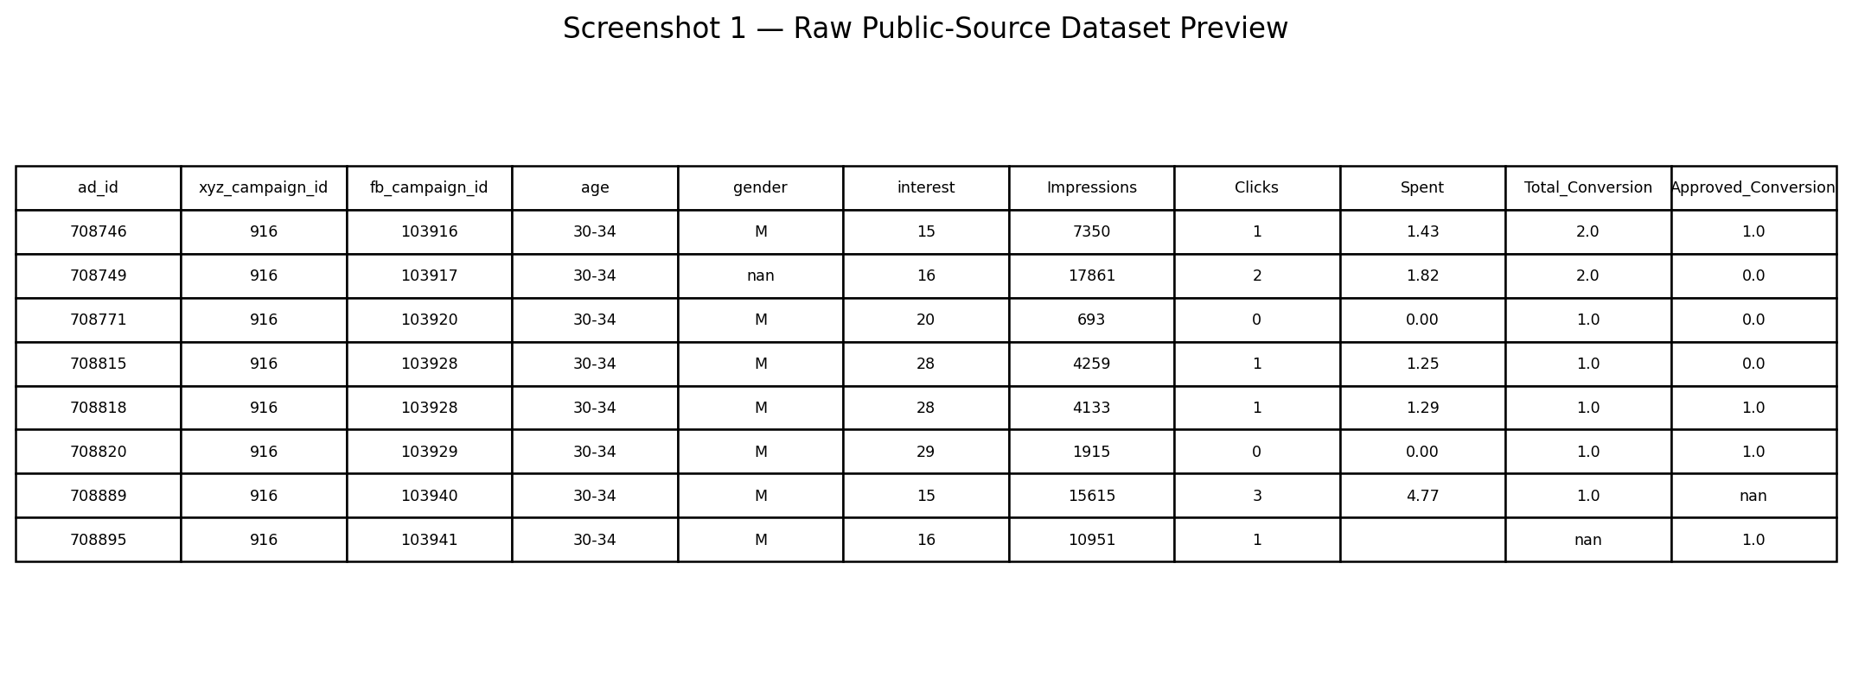
Figure 2. Missing-value profile of the raw dataset used to determine the treatment of incomplete fields.
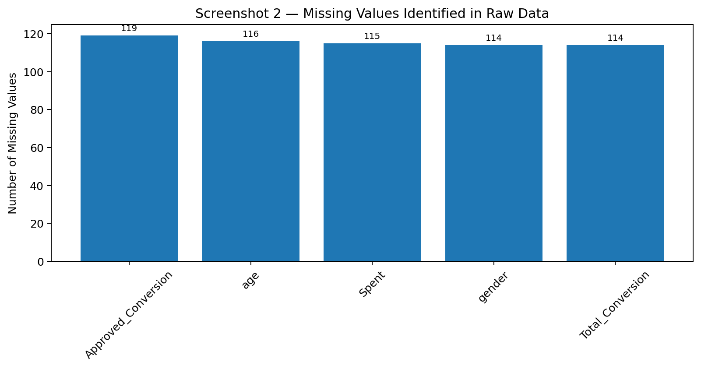
Figure 3. Reduction in row count across the documented cleaning pipeline.
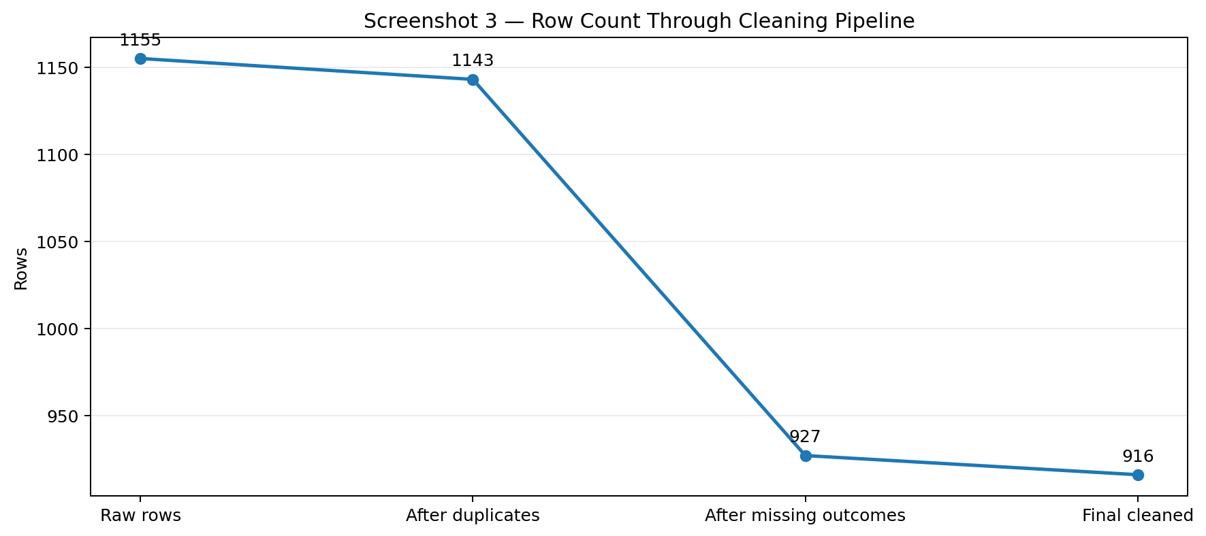
Figure 4. Preview of the cleaned and enriched dataset with derived marketing metrics.
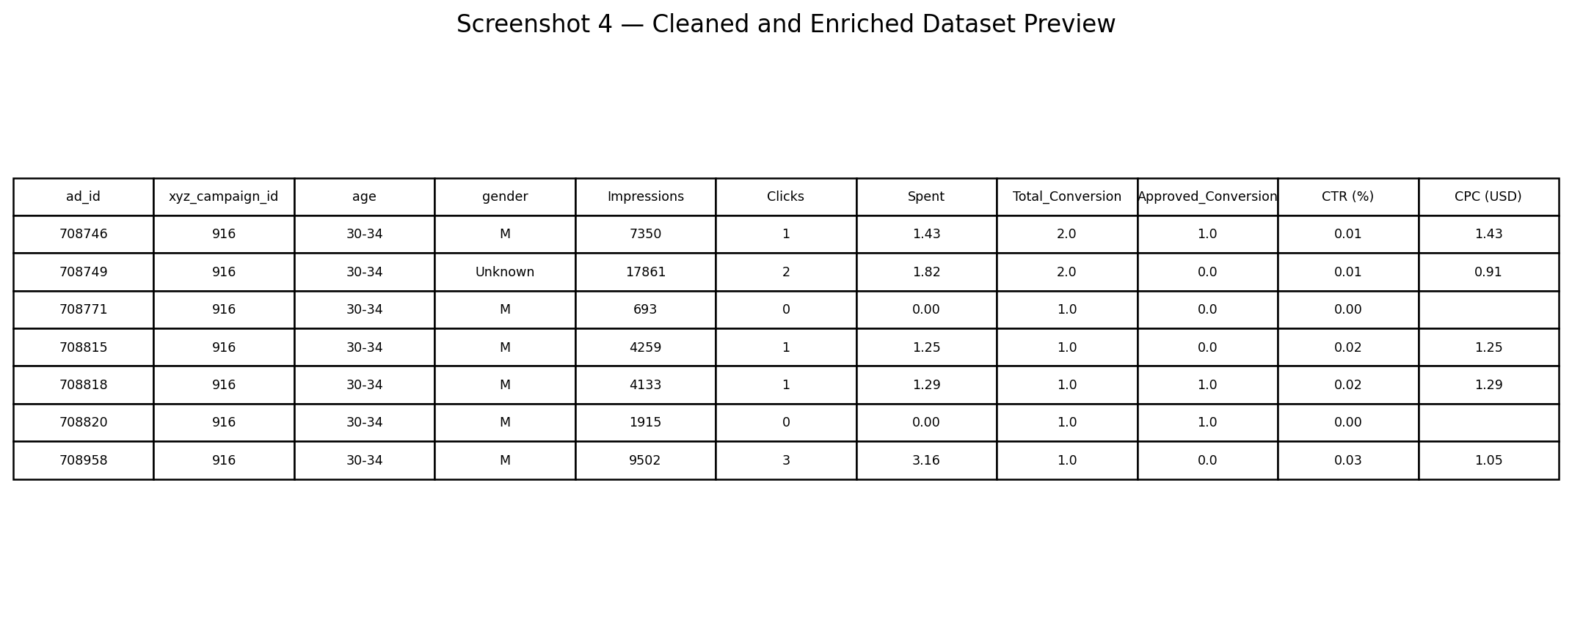
Figure 5. Final validation checks after preprocessing. All documented quality checks return zero exceptions, with 916 final rows.
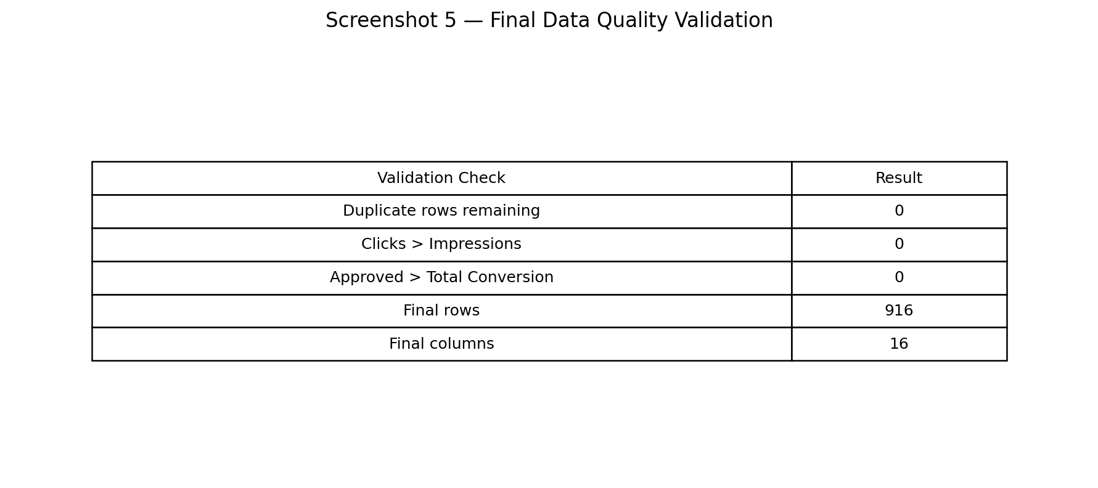

13. Limitations
The dataset is suitable for preprocessing and marketing analytics practice, but several limitations should be considered when interpreting results. First, the source is a public campaign dataset and therefore may not represent the full population of modern digital advertising campaigns or the performance patterns of a particular organization.
Second, the cleaning rules intentionally remove records with missing Total_Conversion or Approved_Conversion because these are outcome variables and were not safely imputed. This improves reliability of the retained records but also reduces the available sample from the raw dataset.
Third, missing Spent values were imputed using the median within the corresponding campaign, with the overall median used as a fallback. This is a practical preprocessing technique, but the imputed values are estimates rather than original observations and should be treated accordingly in downstream analysis.
Fourth, the extreme spend and negative-impression records were treated as data-quality anomalies and removed. This decision is appropriate for producing an internally consistent analytical dataset, but it assumes that these values are erroneous rather than legitimate observations. The cleaning log preserves the decision so that the treatment can be reviewed or changed if additional source documentation becomes available.
Finally, the derived metrics use the available clicks, impressions, spend, and conversion fields. Cases involving zero denominators require care because ratios such as CPC, CTR, CPM, Conversion Rate, and CPA are undefined when their respective denominators are zero. These metrics should therefore be interpreted together with the underlying volume fields rather than in isolation.
For future analysis, the dataset could be extended with additional campaign attributes such as campaign objective, placement, date/time, audience segment, device, geographic region, or creative information if those fields are available from the source. Such additions would support deeper segmentation and more robust campaign-performance analysis.

14. Conclusion
The preprocessing exercise demonstrates how a publicly available marketing campaign dataset can be converted into a structured, analysis-ready resource through a documented sequence of quality checks, cleaning decisions, transformations, and validation procedures.
The original dataset contained 1,155 observations and several practical data-quality issues, including duplicate records, missing demographic and spend fields, incomplete conversion outcomes, negative impression values, and extreme spend values. After applying the documented rules, the final analytical dataset contains 916 observations with the key validation checks passing.
The process also improves the analytical usefulness of the data by adding marketing performance measures such as CTR, CPC, CPM, Conversion Rate, and CPA. These derived measures provide a consistent basis for comparing campaign performance beyond the raw counts of impressions, clicks, spend, and conversions.
Most importantly, the final workbook preserves the distinction between the original source data and the cleaned dataset. The raw data, data profile, cleaning log, cleaned records, and campaign summary are organized separately, while the report explains why each major preprocessing decision was made. This structure makes the work easier to audit, reproduce, and extend in later marketing analytics tasks.
The resulting dataset is therefore suitable as a foundation for subsequent exploratory analysis, campaign comparison, visualization, segmentation, and performance evaluation, subject to the limitations documented above.

